Heat and Geotherm

- In the 1800’s it was recognised that temperatures in mines and caves increased with depth. Listed below are some measurements taken in a rather deep mine. Assume steady-state equilibrium and:
  - Plot the temperature versus depth using an excel spreadsheet.
  - Either by hand or using excel’s linear trend line, draw the best fit straight line through your points and determine the thermal gradient from the slope.
  - Determine the average thermal conductivity from the values given.
  - Use the results from (b) and (c) to determine the heat flux through the surface in this region.

Depth Temperature Conductivity
km °C Watts/(m-°C)
0.0 11.0 2.41
0.5 23.0 2.45
1.0 36.0 2.43
1.5 48.0 2.52
2.0 61.5 2.49
2.5 74.0 2.47
3.0 85.5 2.60
3.5 99.0 2.55
4.0 110.0 2.58

2. The relation of temperature with depth, T(y) inside the Earth may be given by:

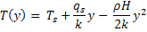
Where T_{s} is the surface temperature, q_{s} is the surface heat flux, k is the thermal conductivity, ρ is the density of the rock and H is the heat generated from radioactive decay.
- If qs = 70mW/m² , ρ = 3 g/cm³, H = 10⁻¹⁰ W/kg, k = 4 Watts/(m − °C) and Ts = 10°C, determine the temperature profile of the upper 200 km within the Earth. Plot these points on the following page.
- Also shown on the graph paper are the liquidus (the line separating the liquid phase (or magma) of a rock from the partially molten phase) and the solidus (the line separating the solid phase of the rock from the partially molten phase), for a peridotite.
    - Determine the depth where the mantle starts to melt.
    - Does this depth correspond with any other observational attribute of the mantle?
    - At what depth is the mantle entirely liquid?
    - What observations tell us that the mantle at this depth does not heat up to such temperatures?
    - How is such melting prevented by the mantle?
- Using the parameters listed in (b), find the temperature in the crust at 5, 10, and 15 km by varying your assumption about the heat generation in crustal rocks: i) assume H = 0; no heat is generated in the rock. ii) assume H =10⁻⁹ watts/kg.
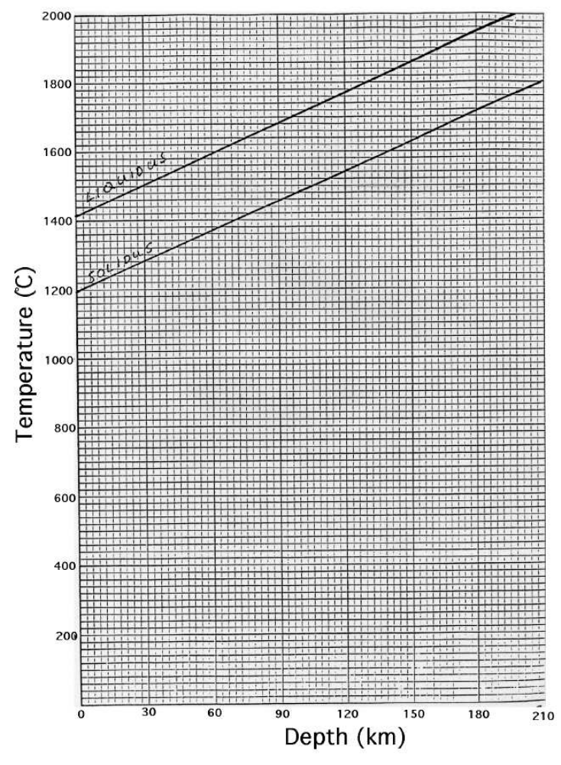

3. Determine the Rayleigh number for the mantle using the following physical parameters:
α = 2 ×10⁻⁵ °C⁻¹,
g = 10 m/s²,
ρ = 3. 5 ×10³ kg/m³,
κ = 10⁻⁶ m²/s,
η = 10²¹ Pas,
ΔT = 3000ºC.

Under what conditions would you expect the solid rock in the mantle to convect?

How does the convection differ for Ra>Ra_{Cr} and Ra>>Ra_{Cr}?

